Article ID: 2014
Article Name: [2014] The light in my cooker hood doesn't work
Topic Location: Cooking hood Usage Performance
Meta-data: no light bulb
Related Articles:
Related Questions:
PNC
DIY
Safety
Link
Email
Book Engineer
Multimedia
Brand
Article Content:
Warning! Disconnect the hood from the electricity supply. Prior to touching the light bulbs ensure they are cooled down
Replace with a new 12 Volt, 20 Watt (Maximum) halogen light made for a G-4 base suitable for use in open Luminaires
Follow the package or user manual directions and do not touch the new light with bare hands.
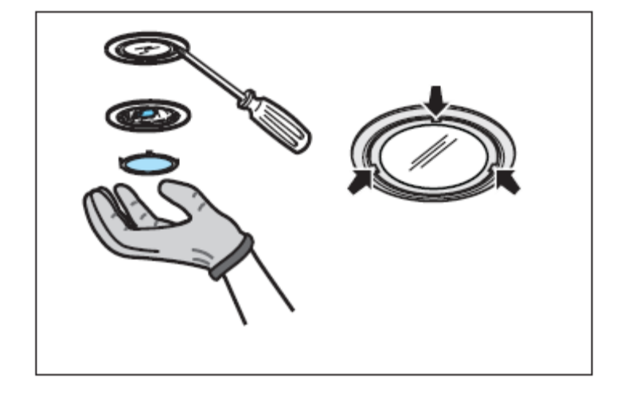

http://shop.electrolux.com/

